 |  |  | Issue #07
Editor: Peter Reed |  | Honouring Sacrifice - Empowering Change
INSIDE  30 years on the streets.  This story, written by Matthew Kelly of Pte Alwyn Craig is unfortunately all too common about Veterans returning from areas of conflict _  .  He used to walk with his head down, he didn't look at anyone  _  Only a select few have been able to make a connection  .  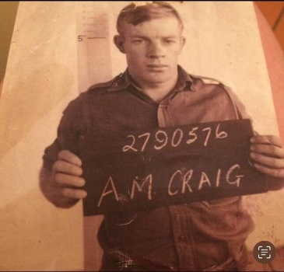  Private Alwyn Craig served in Vietnam. Picture supplied  He was definitely different. He didn’t speak about it [the war] much  The effects of his time in Vietnam became apparent  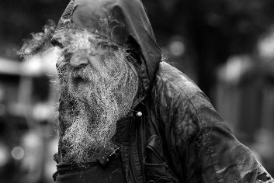  Alwyn roaming the Hunter Street Mall in 2014. Picture by Jonathan Carroll  Felicity Patrick chanced upon a Newcastle Herald story from December 21 last year  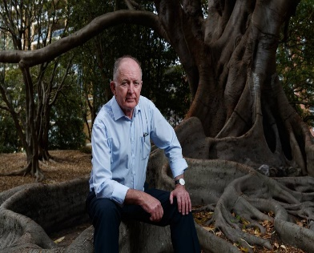  John Cross  Ms Patrick Harold Craigs Daughter Ms Sandy Guido  Alwyn rarely speaks, just a nod here or there  Ken, seeing Alwyn brought tears to his eyes  Alwyn Craig and Lika Ly  Chris (Alwyn) always paid for his coffee  Ruth, gives Ms Ly $50 every month as a gesture of thanks for looking after Alwyn.  After surviving on the streets for 30 years, how can Alwyn be expected to live a normal lifestyle?  Harold is now living in a bus as he can no longer afford to pay rent.  It's going to be very difficult to convince him to give up his entire life for the past 30 years."  Many Vietnam veterans were and are haunted by mental health challenges linked to their military service.  .Newcastle RSL having been alerted look for future support options  Alwyn is really a nice fella, we all want the best for him. |  | 30 years on the streets, ‘Pete’ has reunited with family    Story by Matthew Kelly  First published Newcastle Herald February 10 2024. Brothers reunited. Harold and Alwyn Craig. Pictures by Marina Neil.  Matthew Kelly has worked as a journalist for more than 25 years. He has been working as a general reporter at the Newcastle Herald since 2018. In recent years he has reported on subjects including environment, energy, water security, manufacturing and higher education. He has previously covered issues including the health and environmental impacts of uncovered coal wagons in the Hunter Valley, the pollution of legacy of former industrial sites and freedom of information issues.  Harold Craig takes a deep breath as he struggles to stop his emotions getting the better of him. He's sitting next to his brother Alwyn, whose silent, tormented presence has been a fixture on the streets of Newcastle for three decades.  True to form, Alwyn's blue eyes stare straight ahead, giving nothing away, as Harold tries to come to grips with finding the brother he thought he'd never see again.  A couple of days have passed since Harold travelled from Wollongong to Newcastle to be reunited with 75-year-old Alwyn. He says there's one distinct difference he can see in his brother's demeanor since he last saw him, 30 years ago.  "He walks around with his head up with pride. He didn't do that last time. I noticed that very quickly," he said. "He used to walk with his head down, he didn't look at anyone. Now his head is up. To me, that's a good sign."  The number of people experiencing homelessness in Australia has grown 5.2% in the past five years with women and children, as well as Indigenous Australians, bearing the brunt of the housing crisis.  Until recently, Alwyn was known around the streets of inner Newcastle simply as Pete, his tattered and meandering presence an uncomfortable reminder of the rough underbelly of Australia's largest regional city.  His bedraggled appearance has become the stuff of legend and speculation. Some say he was a judge who fell on hard times. Others believe his family was killed in a car crash. Many have tried to reach out with food, clothing and money. Most have been brushed aside. Only a select few have been able to make a connection with the city's most mysterious resident.  That changed in December, when City Sleep Safe director John Cross was able to help Alwyn, who is mostly non-verbal, to obtain a birth certificate. Since then, a series of extraordinary circumstances have led to a family reunited and a mystery solved, after three long decades.  From Wollongong to Vietnam  Brothers Alwyn and Harold Craig, with only two years between them, were thick as thieves growing up in the idyllic seaside town of Coldale, just north of Wollongong, in the 1950s.  "He was just an ordinary kid; everyone liked him. He was even an altar boy at one time," Harold said.  Alwyn, who has four brothers and two sisters, had jobs working at the local abattoir and as a train station attendant after leaving school.  In late 1968 the then 20-year-old's life changed forever when his name was drawn in the Vietnam War ballot.  After infantry training in Queensland, Private Craig served in the 6th Battalion in Vietnam between May 1969 and May 1970.  Like thousands of others, he struggled to settle back into civilian life.  "He was definitely different. He didn't speak about it [the war] much. He didn't want anything to do with Anzac Day or things like that," Harold, 73, said.  "The effects [of his time in Vietnam] took some time to become apparent, but they expanded as time went on."  His family says his torment was compounded by the news his Vietnamese girlfriend, who he had hoped to bring to Australia and marry, had been murdered by the Vietcong.  Heartbreak and homelessness  Alwyn spend much of the 1970s and '80s drifting between towns and cities in NSW.  He lost touch with his family on numerous occasions but always managed to make his way back to Wollongong. By the early 1990s, Alwyn was living in a small flat in Corrimal, near Wollongong, while undergoing counselling. His family was hopeful this stability and support would finally help him get his life on track.  Then in April 1994 Harold got a call from the real estate agent. Alwyn had left the key in the door of the flat and shot through. Had he seen him?, the agent inquired. He hadn't. Somehow Harold knew his brother wouldn't be back. "We had a bit of a hunt around for him but it was no use; he was gone," he said. He always said he never wanted to be part of society." For three decades his heartbroken family was left without answers.  "Everytime you talk to someone in the family they ask 'have you heard anything about Uncle Ally'," Harold said. "It's affected the entire family, everyone asks everybody on a regular basis."  Answers found in the US  Then, a couple of weeks ago, some late night googling on the other side of the world provided the answers they were looking for. At the same time, it solved an enduring mystery that has gripped Newcastle in recent decades.  Felicity Patrick, who had been adopted out by Alwyn's brother and girlfriend 50 years ago, was sitting in her home in Florida, USA researching her family tree. She chanced upon a Newcastle Herald story from December 21 last year about a plea to help find the city's famous homeless man, known to many simply as "Pete", a permanent home.  The story also contained details of how City Sleep Safe director John Cross had recently helped him obtain a pension and birth certificate, critically revealing Alwyn Melville Craig was born in Lithgow in 1948.  Ms Patrick messaged her cousin, Sandy Guido, Harold Craig's daughter, in Wollongong.  After three decades, Uncle Ally had been found. He wasn't living in Sydney, as many suspected, instead, he had swapped one steel city for another.  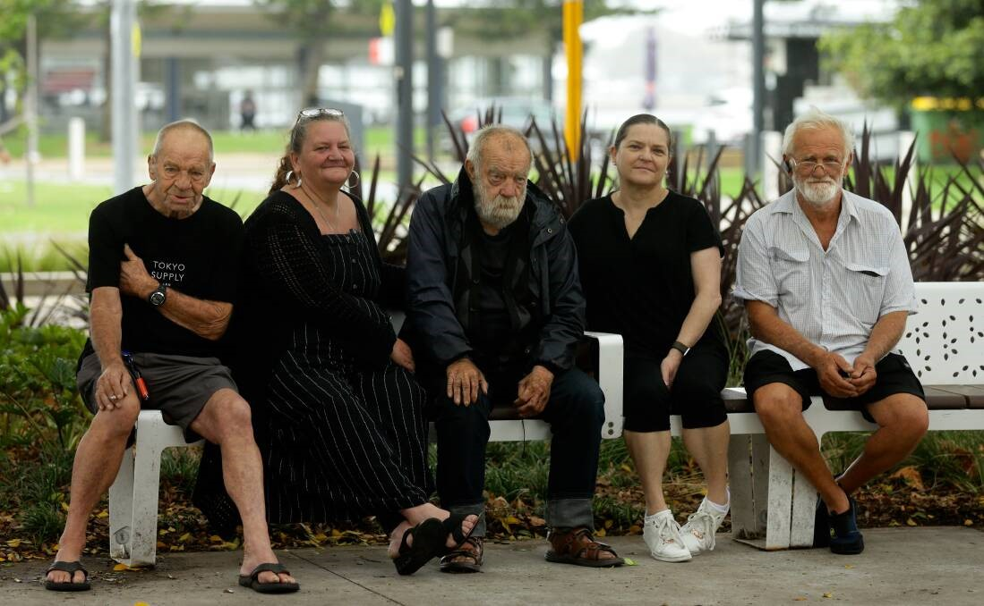  From left: Ken Craig, Kelly Craig, Alwyn Craig, Michelle Baker and Harold Craig in Newcastle this week. Picture by Jonathan Carroll.  Reunion 30 years in the making  Within hours of their discovery, Alwyn's family were making plans to travel to Newcastle and reclaim their brother and uncle.  Harold was the first to arrive late last week.  Mr Cross initially introduced Harold to Alwyn as a friend and left them alone.  Without words, the brothers' bond was rekindled.  "He rarely speaks, just a nod here or there," Harold said. "It's been very emotional. Just in the past few days there have been things that have come from him that I really appreciate."  Earlier this week, other members of the family arrived in Newcastle. Among them was Alwyn's older brother Ken, who bears a striking resemblance to Alwyn.  "[Seeing Alwyn] brought tears to my eyes, put it that way," he said.  "I'd love to catch up with him again. I know I will one day."  Like others, Ken confirmed Alwyn changed after coming home from Vietnam.  During their visit, the Craig family also met and thanked some of the key individuals who interact with Alwyn on a daily basis.  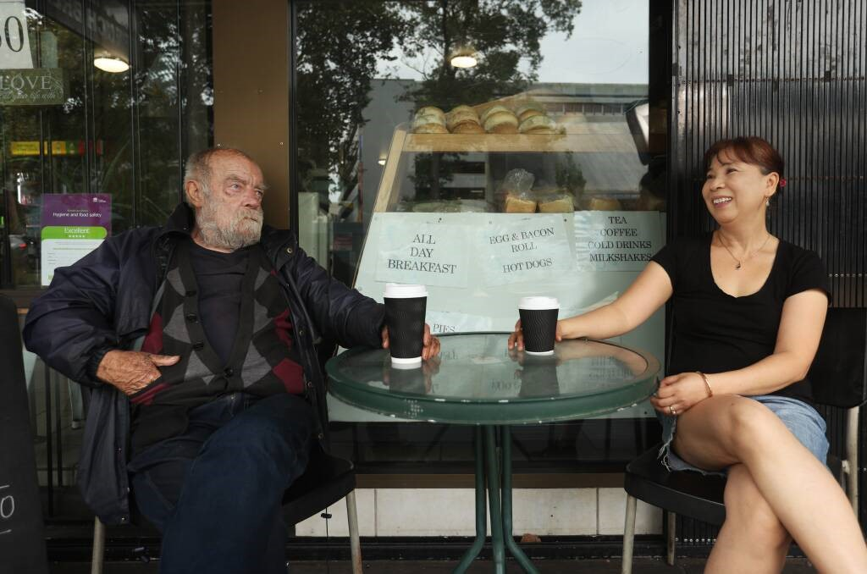  Alwyn Craig with Newcastle French Bread House owner Lika Ly. Picture by Simone De Peak.  Lika Ly owns the Newcastle French Bread House in Hunter Street. For the past 15 years, Alwyn, who she knows as "Chris", has been her special customer.  "He just sits out the front of the shop even if he doesn't buy a coffee. He's very quiet, he never talks," Ms Ly said.  But the passage of time has seen an unspoken rapport evolve.  "He always pays for his coffee. Sometimes the customers want to pay for him but he still puts his money on the counter. If I don't take the money he will never come back. So I take $2 for the big coffee," she said.  "Sometimes we give him an egg and bacon roll but we have to ask him first. If you say 'Chris, you feel like an egg and bacon roll today?' and he says 'yes' you can bring it out. But if you just make it and bring it out he won't eat it."  There are others in the background who also play a role in sustaining Alwyn.  They include local resident Ruth, who gives Ms Ly $50 every month as a gesture of thanks for looking after Alwyn.  The path forward  A lot has changed in the past few weeks since Alwyn was "discovered".  Multiple discussions are under way about how he can be best supported moving forward. But after surviving on the streets for 30 years, how can he be expected to live a normal lifestyle?  "I'd like to see him come back home but I don't think that's going to happen," Ken Craig said.  The bus is my home and his (Alwyn's) home is that shop doorway. It's going to be very difficult to convince him to give up his entire life for the past 30 years.  Harold Craig agrees.  "I love him dearly but it's knocking the shit out of me knowing I can't just take him by the hand and say let's go. You can't do it, it's not reality," he said.  "We'd all like to march him into a spa bath and shower him with champagne. Movies are like that but life's not."  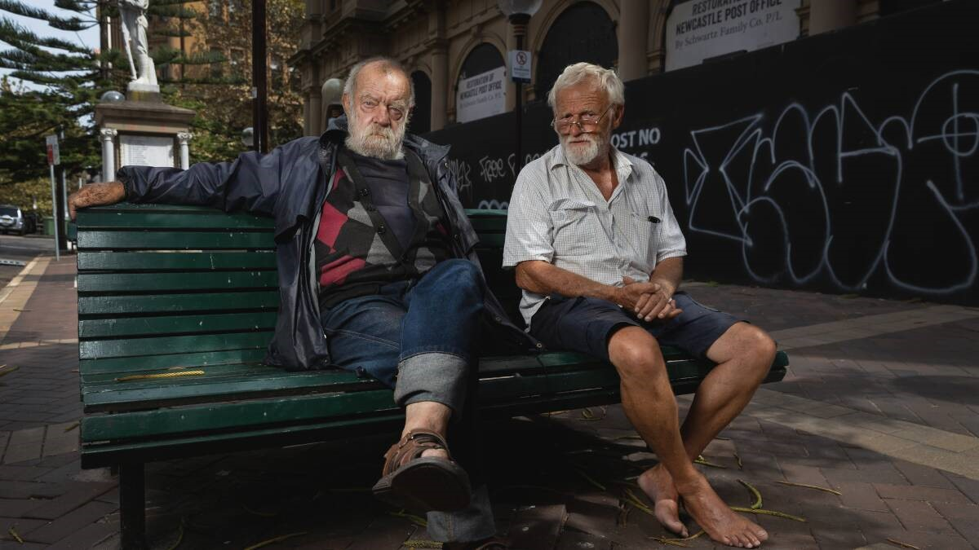  Alwyn and Harold Craig outside Newcastle Post Office this week. Picture by Marina Neil.  Unable to afford a place to rent, Harold has recently resorted to living in a bus. He is supported by his family, who paid for the fuel to travel to Newcastle.  He says he relates to his brother's daily routine and its role in his survival.  "He has his routine every day and I have mine. I live local [in Wollongong] and there's one spot where I go back to every day and he has got his spot where he goes back to every day to sleep," he said.  "I have been living in my bus now for six months now and I've got to the point where I don't like going into houses. The bus is my home and his (Alwyn's) home is that shop doorway. It's going to be very difficult to convince him to give up his entire life for the past 30 years."  Pain resurfacing  It's also likely that changes to Alwyn's lifestyle would require him to re-engage in some way with his past and the pain that lies there.  Former Newcastle Vietnam Veterans Association president Stephen Finney said many Vietnam veterans were haunted by mental health challenges linked to their military service.  "A lot of them didn't want to be there. They were shit-scared for the 12 months they were there and when they came home nobody recognised them as servicemen," Mr Finney said.  "The RSLs (clubs) didn't want to know us. It was awful trying to fit back into society.  "You couldn't talk to anybody about it because you didn't know what sort of reaction you were going to get from the person you were talking to.  "The experience drove a lot of people into holes and solitude."  Having been alerted to his presence in Newcastle, RSL Lifecare sent a representative to meet Alwyn, Mr Cross and Harold this week to discuss future support options, including housing.  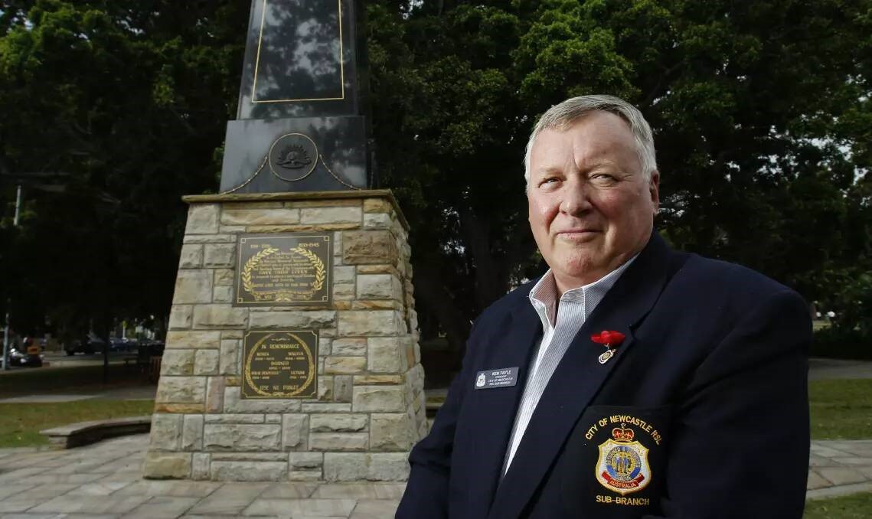  Newcastle RSL sub-branch president Ken Fayle. Picture by Max Mason Hubers  Newcastle RSL sub branch president Ken Fayle said it was overwhelming to learn Alywn had been living unrecognised in the Newcastle community for 30 years. "Every Vietnam Vet feels for Pete," he said. "There were so many guys who knew of him but they didn't know anything about him. "When we know what we can do, we will help."  The one person who probably knows Alwyn better than anyone, John Cross, said he was optimistic the events of the past fortnight would be good for his friend.  "He's a really nice fella, you can see he doesn't get too excited but he's watching everything that is going on," he said.  "We all want the best for him, but ultimately what that looks like will be up to him

